ECO101: INTRODUCTION TO MICROECONOMICS

BRAC UNIVERSITY

Week 2 and 3 - Demand, Supply, Equilibrium

# DEMAND AND SUPPLY

**“TEACH A PARROT THE TERMS SUPPLY AND DEMAND AND YOU’VE GOT AN ECONOMIST.”**

* **THOMAS CARLYLE**

# Lecture 5_Demand

## **DEMAND**

* Demand means a willingness and capacity to pay.  
  Unless you are willing and able to pay for it, you may want it, but you don’t demand it.
* **Three main characteristics of demand**
* **(i)** Willingness and ability to pay.
* **(ii)** Demand is always at a price.
* **(iii)** Demand is always per unit of time.

## **DEMAND SCHEDULE AND DEMAND CURVE**

* A ***demand schedule*** is a table showing how much of a given product a household would be willing to buy at different prices.
* The ***demand curve*** is a graph illustrating how much of a given product one would be willing to buy at different prices.
* Demand curves are usually derived from demand schedules.

## **DEMAND SCHEDULE VS DEMAND CURVE**

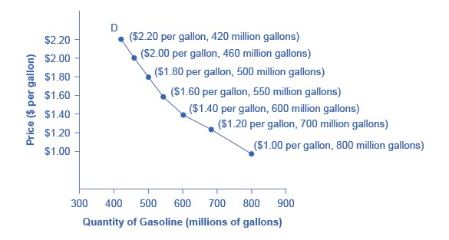

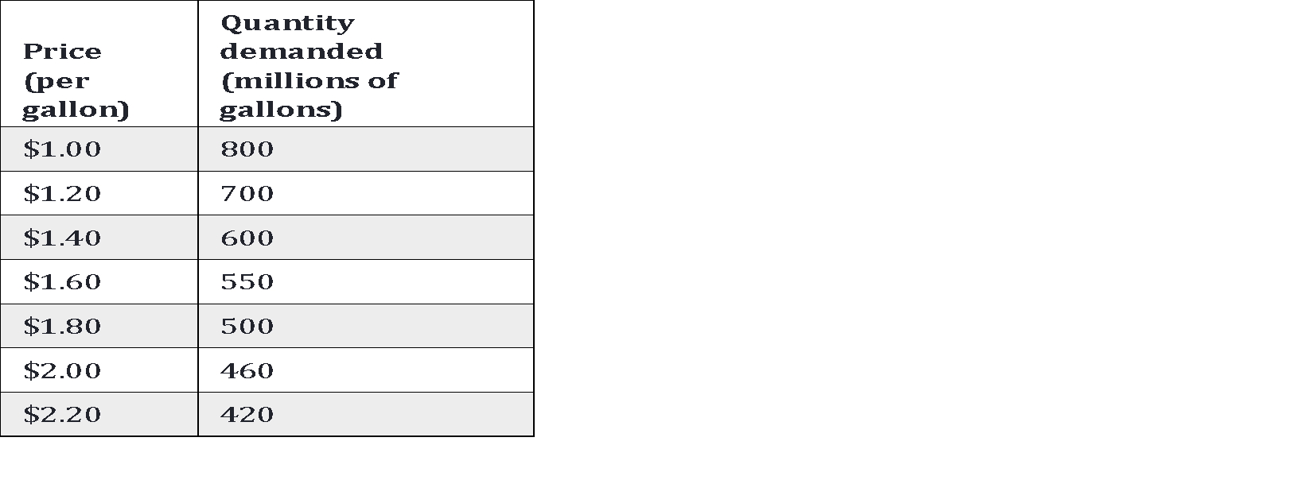

**Demand schedule Demand curve**

## **DEMAND VS QUANTITY DEMAND**

* Demand is not the same as Quantity Demanded.
* **Demand** shows the relationship between a range of prices and the quantities demanded at those prices, as illustrated by a demand curve or a demand schedule.
* **Quantity demanded** means only a certain point on the demand curve or one quantity on the demand schedule.
* In short, **demand refers to the curve**, and **quantity demanded refers to a specific point on the curve.**

## **The Law of Demand**

Ceteris paribus, an **increase** in price causes a **decrease** in the quantity demanded or a **decrease** in price causes an **increase** in quantity demanded.

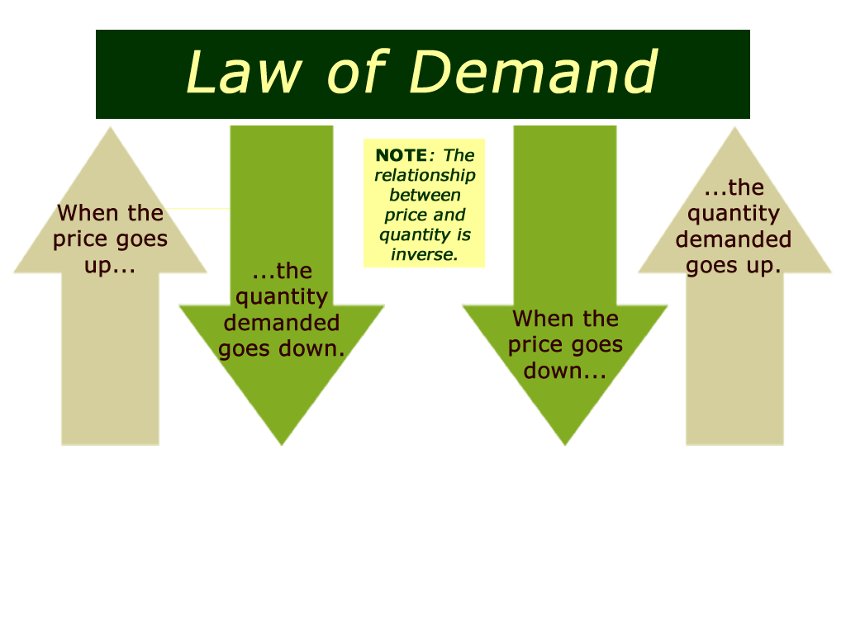

## **WHY DOES THE DEMAND CURVE SLOPE DOWNWARD?**

* The law of demand states that as the price goes up, the quantity demanded goes down, other things constant.
* An alternative way of saying the same thing is that price and quantity demanded are inversely related, so the demand curve slopes downward to the right.

## **SHIFT OF DEMAND VERSUS MOVEMENT ALONG A DEMAND CURVE**

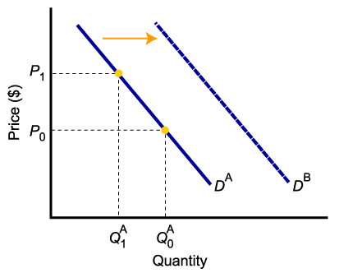

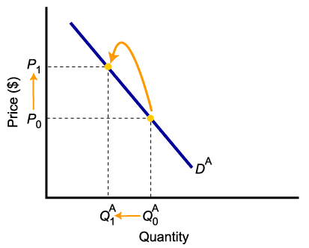

* A change in ***demand*** is not the same as a change in ***quantity demanded***.
* In the left diagram, a higher price causes lower ***quantity demanded***.
* Changes in determinants of demand, other than price, cause a change in ***demand***, or a ***shift*** of the entire demand curve, from *D*A to *D*B.

## **A CHANGE IN DEMAND VERSUS A CHANGE IN QUANTITY DEMANDED**

* When ***demand shifts*** to the right, demand increases. This causes ***quantity demanded*** to be greater than it was prior to the shift, ***for each and every price level.***

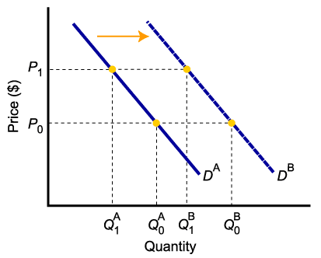

# Lecture 6_Determinants and Factors Affecting Demand

## **DETERMINANTS OF DEMAND**

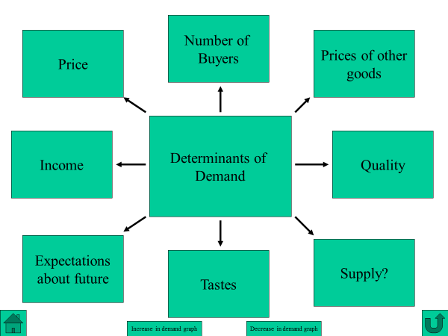

## **PRICE**



* Price is the most important determinant of demand.
* A “demand curve” plots combinations of prices and quantity demanded.
* A change in price causes a movement along the demand curve

## **FACTORS AFFECTING DEMAND (OR, SHIFT FACTORS OF DEMAND)**

* **1. Income**
* **2. The Prices of Related Goods**
* **3. Tastes and Preferences**
* **4. Expectations about Future Prices and Market Conditions**
* **5. Population/ No of Consumers**

## **INCOME**

* Ceteris paribus, when people’s income changes, demand change (shifts in demand)
* Normal Goods – A good whose demand increases with an increase in income is called a “normal good.”
* Inferior Goods –A good whose demand decreases with an increase in income is called an “inferior good.”

Normal Goods – For normal goods demand increases with an increase in income or vice-versa.

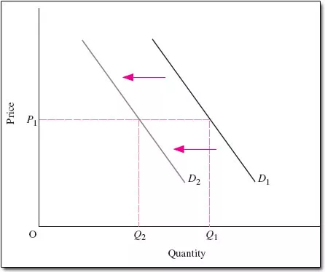

Lower income => lower demand

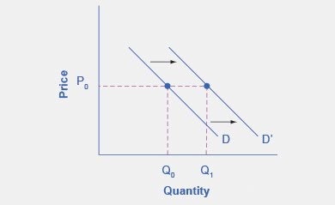

Higher income => higher demand

Inferior Goods –For inferior goods demand decreases with an increase in income or vice-versa.



Higher income => lower demand



Lower income => higher demand

## **PRICES OF RELATED GOODS**

* Changes in the prices of related goods can increase or decrease demand.
* Substitute Goods: Two goods are substitute goods if an increase in price of one good causes an increase in the demand for another good.
* Complementary Goods: Two goods are complementary goods if an increase in price of one good cause a decrease in the demand for another good.





## **TASTES AND PREFERENCES**

* Demand curve can shift due to changes in tastes over time.



Unfavorable change in taste => lower demand



Favorable change in taste => higher demand

## **EXPECTATIONS ABOUT FUTURE PRICES AND MARKET CONDITIONS**

* Demand curve can shift due to changes in expectations.
* For example, if you expect the price of computers to fall soon, you may put off buying one until later.

Negative expectation=> lower demand



Positive expectation=> higher demand

## **POPULATION/ NO OF CONSUMERS**

decrease in population/no of consumers => lower demand



Increase in population/no of consumers => higher demand

# LECTURE 7: SUPPLY

## **SUPPLY SCHEDULE AND SUPPLY CURVE**

* A ***supply schedule*** is a table showing how much of a product firms(producers) will supply at different prices.
* The ***supply curve*** is a graph illustrating how much of a given product firms(producers) would be willing to sell at different prices.

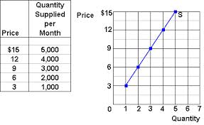

**Supply schedule Supply curve**

## **SUPPLY VS QUANTITY SUPPLIED**

* Supply is not the same as Quantity supplied.
* Supply **refers to the curve**, and quantity supplied **refers to a specific point on the curve.**

## **THE LAW OF SUPPLY**

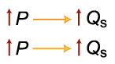

* The ***law of supply*** states that there is a positive relationship between price and quantity of a good supplied.
* This means that supply curves typically have a positive slope.

## **MOVEMENT ALONG THE CURVE VS. SHIFT IN THE SUPPLY CURVE**

Change in costs, input prices, technology, or prices of related goods and services leads to a change in supply

(**Shift of curve**).

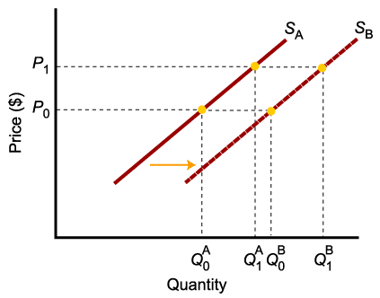

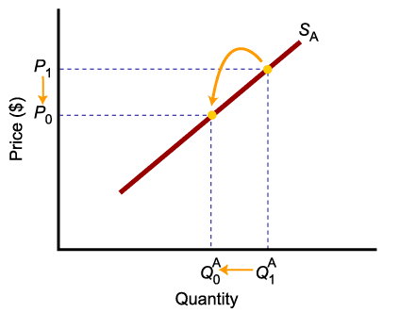

Change in price of a good or service

leads to a change in *quantity supplied* (**Movement along the curve**).

## **DETERMINANTS OF SUPPLY**

* The ***price*** of the good or service.
* The ***cost*** of producing the good, which in turn depends on:
  + Price of Inputs (labor, capital, and land),
  + Technology
* Expectations
* Government Policy (Taxes, Subsidies and Regulations)
* Competition

## **PRICE**



A change in price causes a movement along the supply curve

## **SHIFT FACTORS OF SUPPLY**

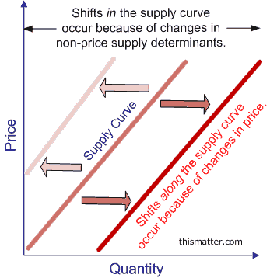

A **right** shift means an **increase** in Supply

A **left** shift means a **decrease** in Supply

**Price of Inputs (labor, capital, and land)**

* If input costs rise with no change in output, profits will decline, and a firm has less incentive to supply and vice-versa.

**Technology**

* New technology can **reduce the costs of production**, leading to an increase in supply

**Expectations**

* Supplier expectations are an important factor in the production decision.
* If a supplier expects the price of the good to rise at some time in the future, it may store some of today’s supply to sell it later and reap higher profits, decreasing supply now and increasing it later.

# Lecture 8: Market Equilibrium

## **Market Equilibrium**

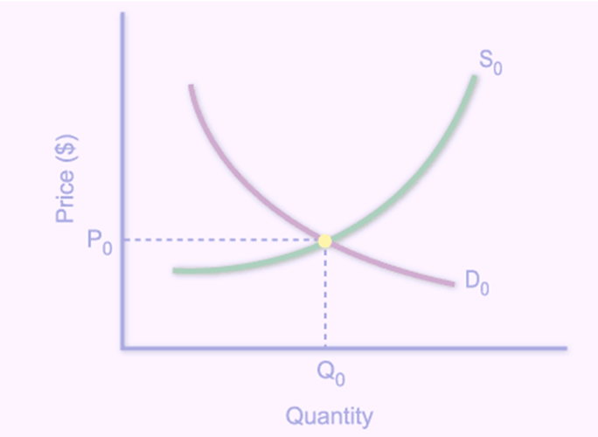

The *market equilibrium price* is the price at which the quantity demanded equals the quantity supplied.

The *market equilibrium quantity* is the quantity bought and sold at the equilibrium price.

Quantity Quantity Shortage(–)

Price demanded supplied or surplus (+)

(dollars   
of bars) (millions of bars per week)

0.50 22 0 –22

1.00 15 6 –9

1.50 10 10 0

2.00 7 13 +6

2.50 5 15 +10

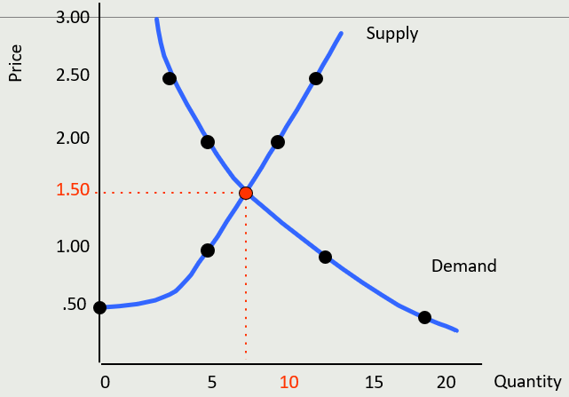

## **Market Disequilibria: Shortages**

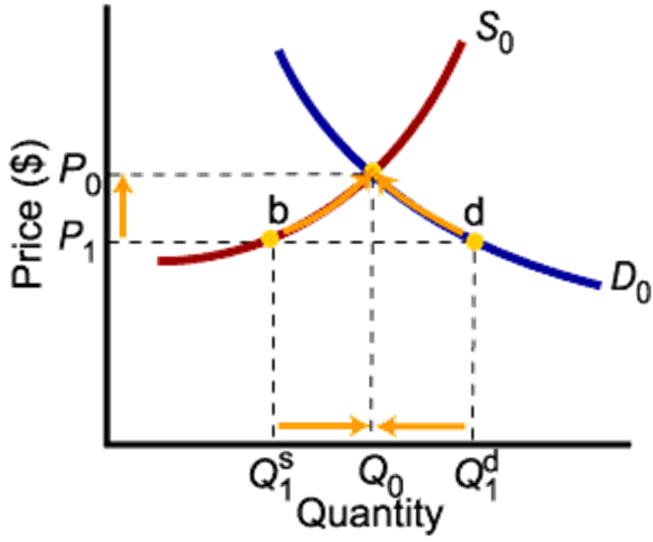

If the price is too low, the quantity demanded exceeds the quantity supplied. People are willing to pay more for the good.

To eliminate this *shortage*, sellers will raise the price, increasing the quantity supplied and reducing the quantity demanded.

## **Market Disequilibria: Surpluses**

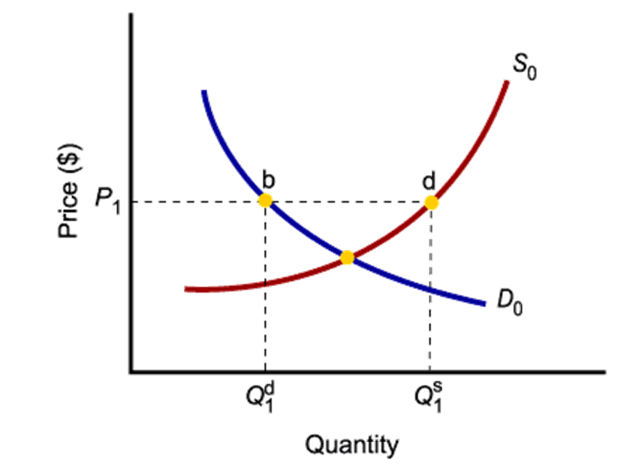

If the price is too high, the quantity supplied exceeds the quantity demand. Inventories pile up.

To eliminate this *surplus*, sellers will lower the price, reducing quantity supplied and increasing quantity demanded.

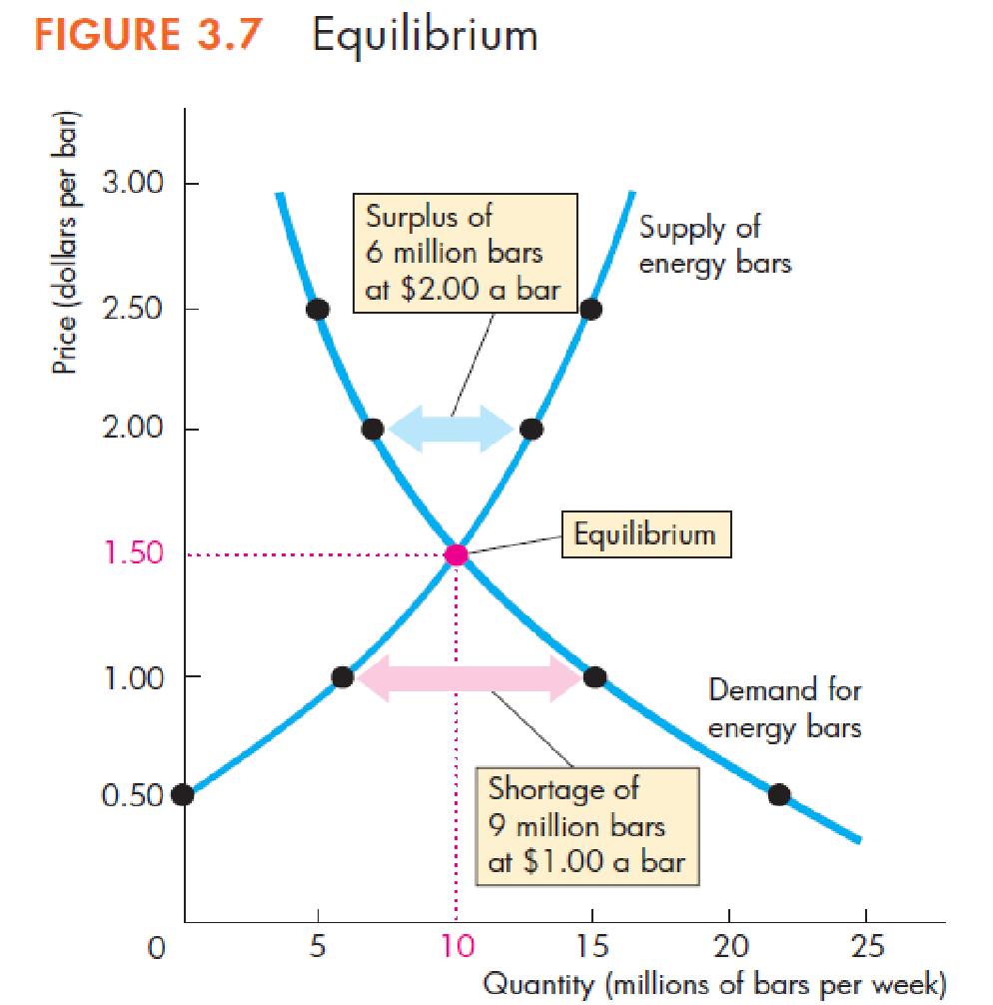

A Shortage Forces the Price Up

If demand exceeds supply, sellers will raise price, decreasing quantity demanded.

A Surplus Forces the Price Down

If supply exceeds demand, sellers will see their inventories of unsold goods piling up and will cut price to sell them.

# Lecture 9: Predicting changes in Market Equilibrium

## **Predicting Changes in Price and Quantity**

A change in price and quantity must be caused by either a change in demand or a change in supply or both!

**Demand Decreases if:**

■ The price of a substitute falls

■ The price of a complement rises

■ The expected future Price or income falls

■ Income falls*

■ No of consumer/ population decreases

*considering normal goods

**Demand Increases if:**

■ The price of a substitute rises

■ The price of a complement falls

■ The expected future Price or income rises

■ Income rises*

■ No of consumer/ population increases

*considering normal goods

## **Effect of An Increase in Demand on Equilibrium Price and Quantity**

An increase in demand shifts the demand curve to the right (outward shift in demand).

The new equilibrium price and quantity are higher.

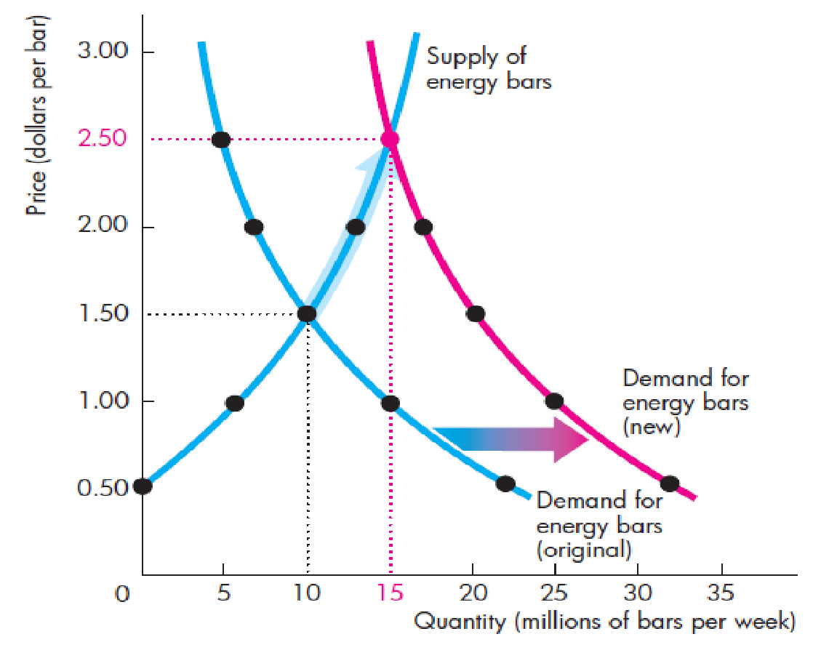

## **Effect of A decrease in Demand on Equilibrium Price and Quantity**

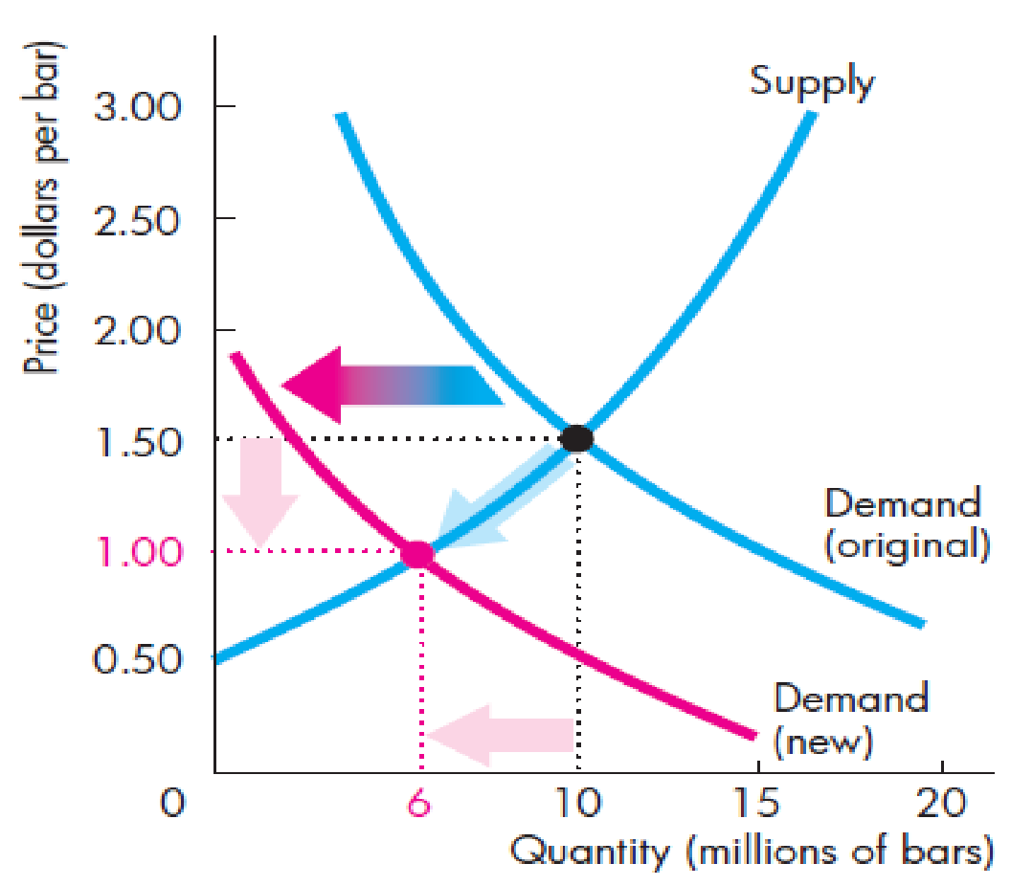

A decrease in demand shifts the demand curve to the left (inward shift in demand).

The new equilibrium price and quantity are lower.

**Supply Decreases if:**

■ The price of a factor of production (input price, technology) rises

■ Unfavorable govt. policy

■ The expected future price falls

■ The number of suppliers of bars increases

■ The price of a substitute in production rises

■ The price of a complement in production falls

■ A unfavorable natural event decreases production

**Supply Increases if:**

■ The price of a factor of production (input price, technology) falls  
■ Favorable govt. policy

■ The expected future price falls

■ The number of suppliers of bars increases

■ The price of a substitute in production falls

■ The price of a complement in production rises

■ A favorable natural event increases production

## **Effect of An Increase in Supply on Equilibrium Price**

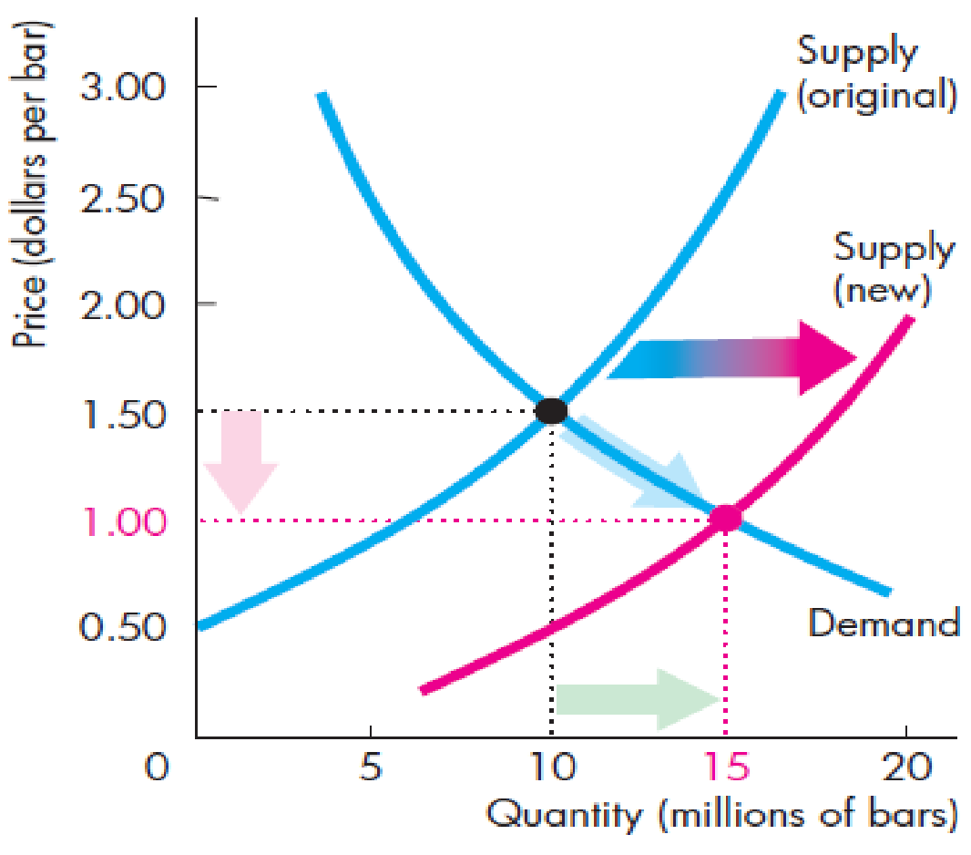

An increase in supply shifts the supply curve to the right (outward shift in supply).

The new equilibrium price is lower, but the equilibrium quantity is higher.

## **Effect of A Decrease in Supply on Equilibrium Price**

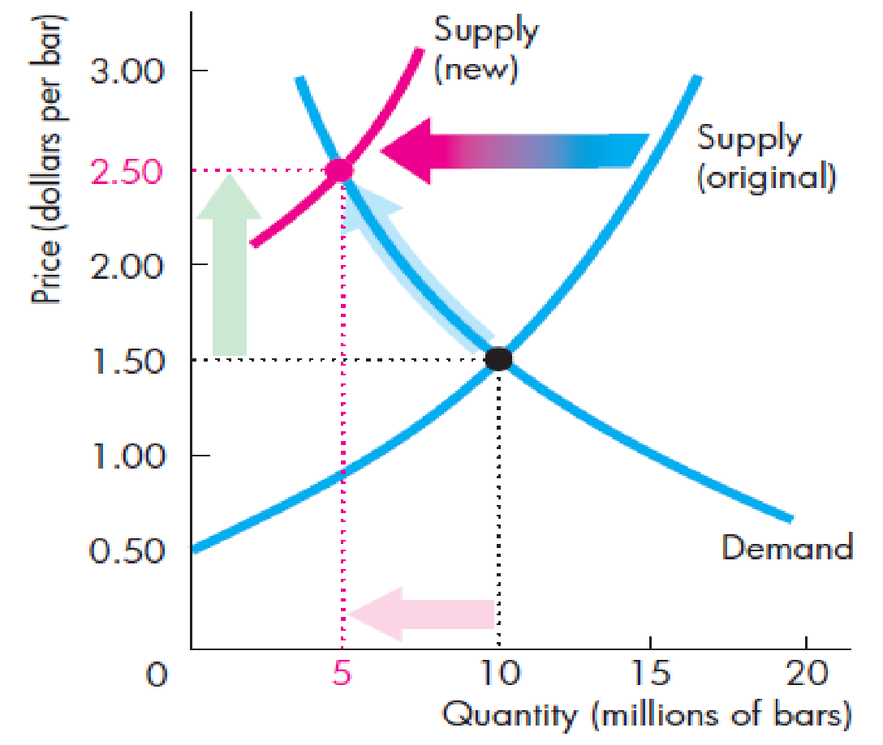

A decrease in supply shifts the supply curve to the left (inward shift in supply).

The new equilibrium price is higher, but the equilibrium quantity is lower.

## **A Change in Both Demand and Supply**

* There are four possible scenarios-
  1. Both demand and supply increase
  2. Both demand and supply decrease
  3. Demand increases and supply decreases
  4. Demand decreases and supply increases
* Effects-
  1. Both curves shift.
  2. Price and quantity change will depend on how each curve shifts on which direction.

## Both demand and supply increase

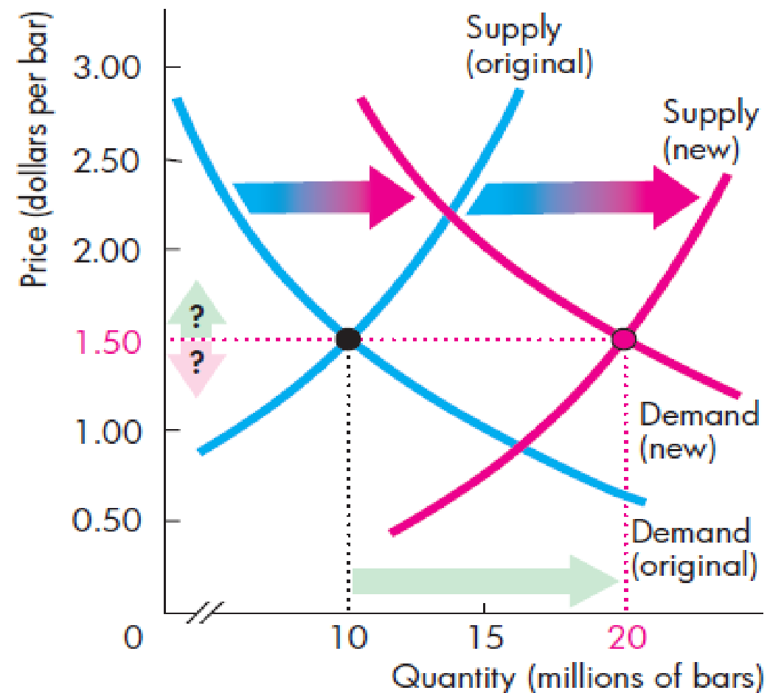

* **If demand and supply increase**, both the demand and supply curves shift to the right (outward).
* Effect on equilibrium price and quantity
  + The new equilibrium quantity will be higher.
  + The new equilibrium price may be higher, lower, or it may remain the same.

## Both demand and supply decrease

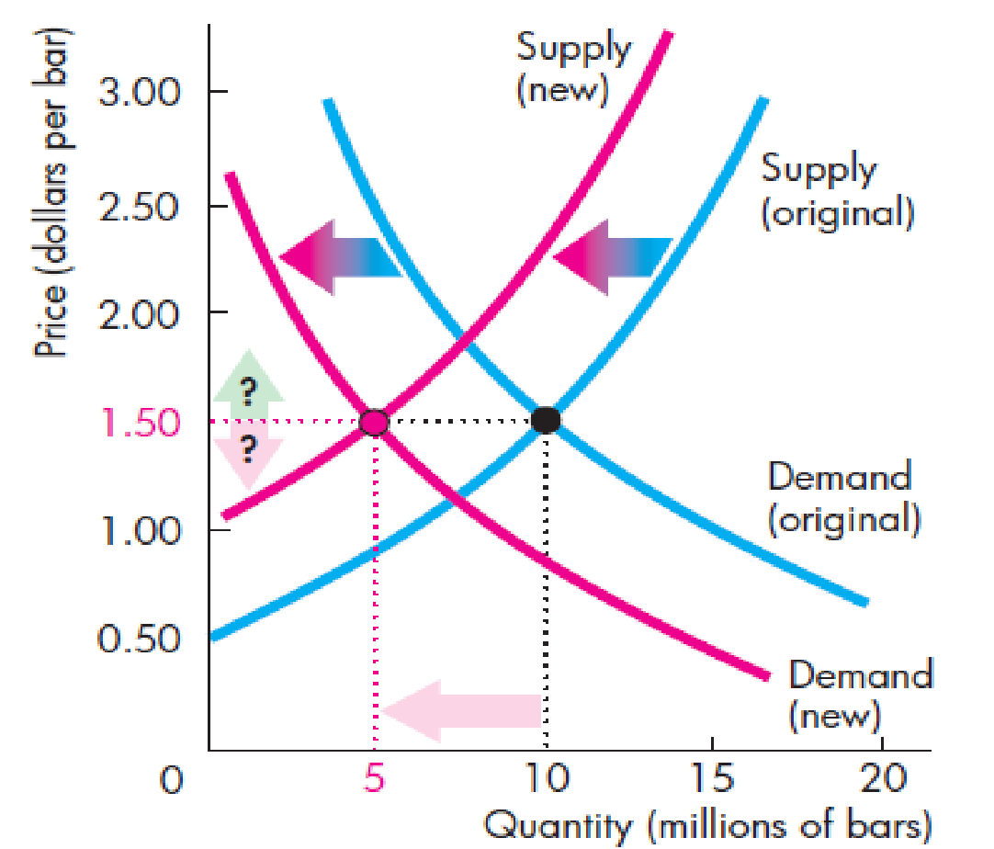

* **If demand and supply decrease**, both the demand and supply curves shift to the left (inward).
* Effect on equilibrium price and quantity
  + The new equilibrium quantity will be lower.
  + The new equilibrium price may be higher, lower, or it may remain the same.

## Demand increases and supply decreases

* **When demand increases,** demand curve shifts to the right (outward).
* **When supply decreases**, supply curves shift to the left (inward).
* Effect on equilibrium price and quantity
  + The new equilibrium price will be higher.
  + The new equilibrium quantity may be higher, lower, or it may remain the same.

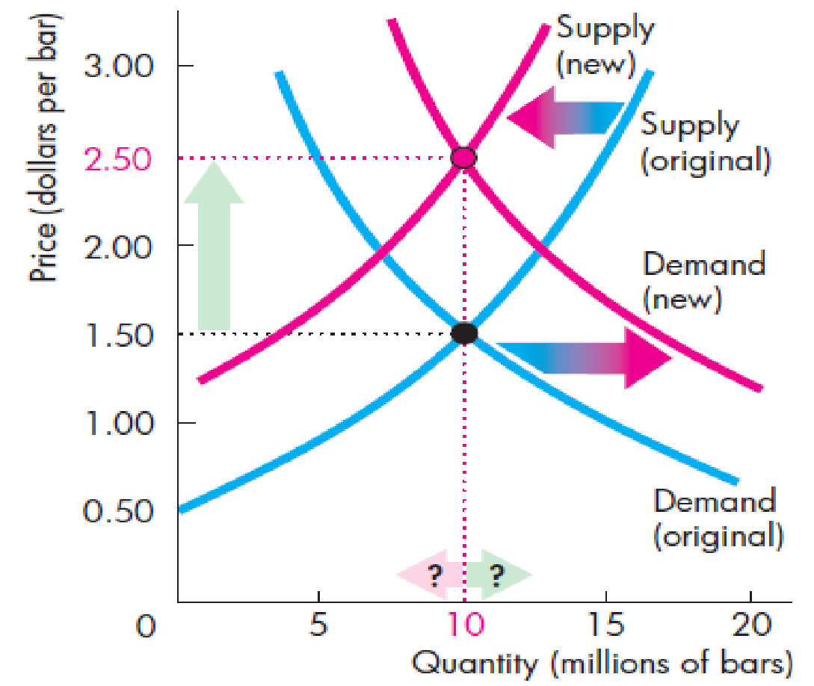

## Demand decreases and supply increases

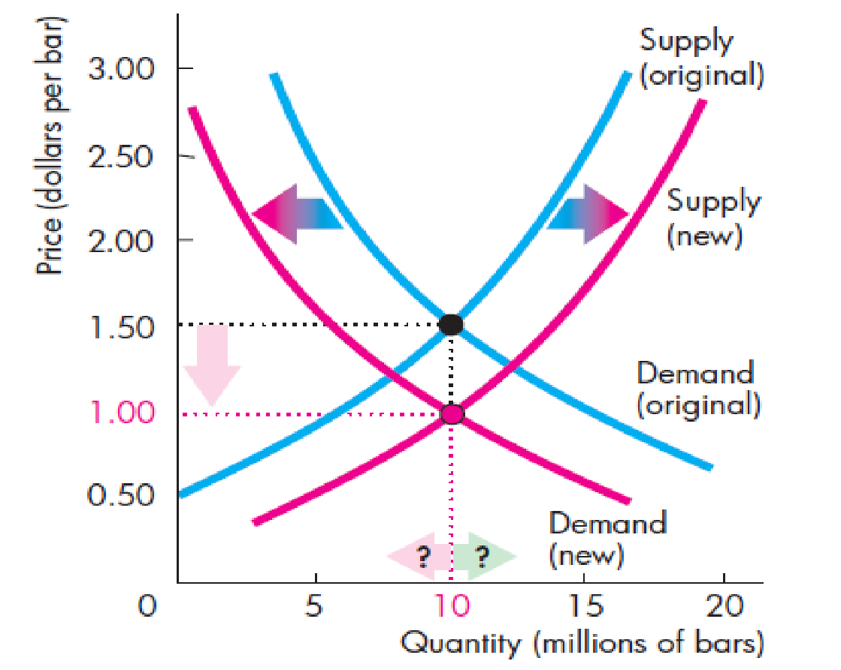

* **When demand decreases,** demand curve shifts to the left (inward).
* **When supply increases**, supply curves shift to the right (outward).
* Effect on equilibrium price and quantity
  + The new equilibrium price will be lower.
  + The new equilibrium quantity may be higher, lower, or it may remain the same.